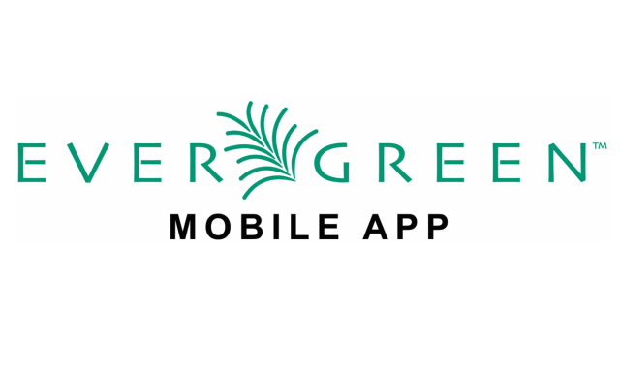

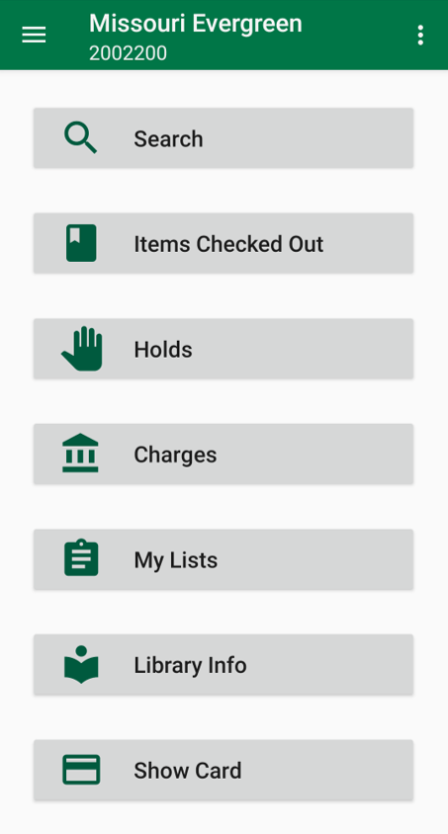

Searching our collection and placing holds just got easier! Now, you can access your account, find your favorite authors, and request items through the new Missouri Evergreen app, available on Apple and Android devices.

After downloading the app, you’ll need to log in with your card number and your PIN (the last four digits of your card number unless you have changed it).

Once you are logged in, you can search the catalog, view the items you have out, view your current holds (and if they have arrived), any bills you might have (listed as charges), find lists you’ve created, see your local library’s information, and even display your card’s barcode!

We are here to help if you have any questions.